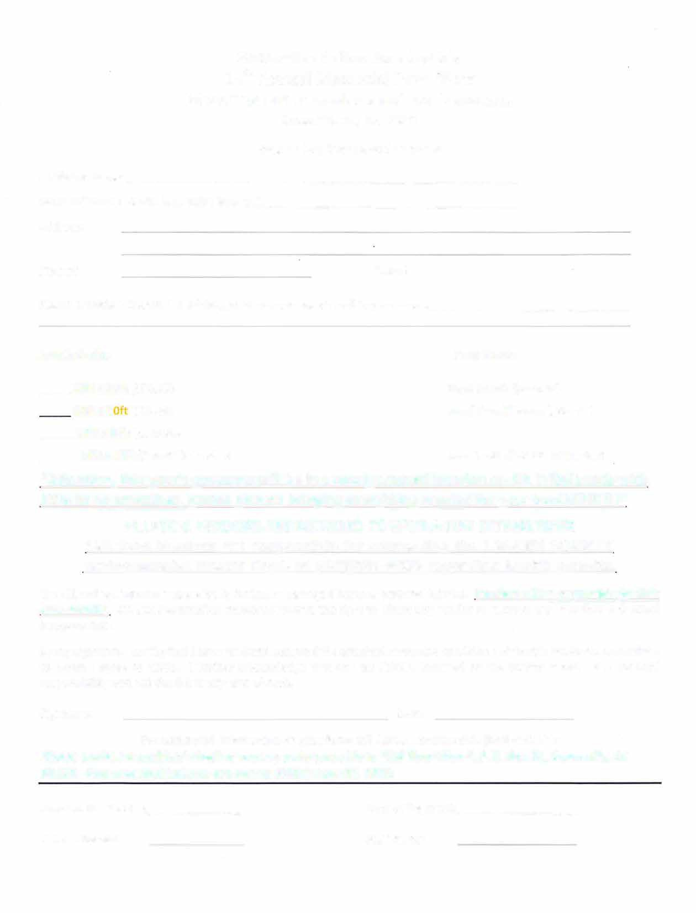Susanville Indian Rancheria' s 14th Annual Memorial Pow-Wow
Honoring our Ancestors and our Veterans

June 23, 24, 25 2023

Vendor Application and Contract
Applicant Name: _ Name of Vendor Booth (e.g. Bob's Burgers): ____________________________________ Address:

Phone# E-Mail: --------------
Please provide a description of the goods that you plan to sell in your booth__

Arts & Crafts: Food Booth:

10ft x 10ft ($5O.O0) Food Booth ($200.00)
10ft X 2 ($75.00) Small Food/Drinks ($100.00)

10ft X 30ft ($125.00)
10ft x 10ft ($30.00 for 1 day) Info Booth ($25.00) (NO sales)

ALL INDIAN TACO VENDORS ARE REQUIRED TO HAVE A CLASS "K" FIRE EXTINGUISHER
* All food Vendors are responsible for contacting the LASSEN COUNTY Environmental Health Dept. at (530)251-8528 regarding health permits.
The SIR will not assume responsibility for lost or damaged items or personal injuries. Vendors will be responsible for their own security. SIR staff/committee members reserve the right to direct any vendor to remove any item that is deemed inappropriate.
By my signature, I certify that I have read and accepted the attached terms and conditions of the SIR Pow-Wow Committee to which I agree to abide. I further acknowledge that any tax liability incurred by the vendor remains the vendors' responsibility and not the SIR or any arm of such.

Signature: Date:

For additional information or questions; call dakota Baez (530) 260-1854 or Erma Hart (530) 310-0272
Please enclose a cashiers' check or money order payable to "SIR Pow-Wow", P.O. Box 54, Susanville, CA 96130. Fees and applications are due by Friday June 02, 2023.

Amount Received: $------ Form of Payment: __
Date of Receipt: Staff Name:


Susanville Indian Rancheria Memorial Pow-Wow Terms and Regulations

Informational and arts/crafts Vendors are required to donate an item to the SIR Pow-Wow Committee for the Raffle. Booth spaces are generally 10 x 10 or larger. Spaces will be assigned at the sole discretion of the committee.

*All food Vendors are responsible for contacting the Susanville Environmental Health Department at {530) 251-8528 regarding health permits.

Setup begins on Friday at 9:00 AM. Vendors will receive 45 minutes to unload after which vehicles will need to be moved.

*Vendors must provide their own canopy, tables, chairs, and electricity (i.e., Whisper Generator) if outside.
The vendor agrees to abide by all Local, State, Federal, and Tribal laws. The vendor agrees that all Federal, State, and Local taxes are the vendors' responsibility.

Vendors also agree to abide by and comply with the Indian Arts and Crafts Act of 1990 (P.L. 101-644), which prohibits misrepresentation in the marketing of Indian arts and crafts products within the United States. The Indian Arts and Crafts Act of 1990 is a truth-in-advertising law. It is illegal to offer or display for sale or sell any art or craft product in a manner that falsely suggests it is an Indian product or the product of a particular Indian tribe.

No vendor, other than those who have contracted with and were selected by the SIR Powwow Committee shall be permitted to sell any food or drinks during the SIR Powwow.

NO ALCOHOL, DRUGS, WEAPONS, FIREARMS, EXPLOSIVES, EXPLOSIVE DEVICES, OR PRODUCTS
WITH OFFENSIVE ODORS ARE ALLOWED ON THE PREMISES. If any of the above-mentioned items are discovered on the premises or displayed in any manner will result in immediate expulsion from the SIR Pow-Wow and denied entry for the remainder of the event. THERE WILL BE NO REFUNDS!!

Absolutely no garage sale, flea market, junk items, illegal, or items of bad taste will be allowed. The Pow-Wow Committee reserves the right to request that any inappropriate items be removed.

The Pow-Wow Committee reserves the right to cancel this agreement at any time. In such case, all vendor fees will be refunded, unless the cancellation was due to a violation of the contract. All decisions of the Pow-Wow Committee are final. **If a Vendor cancels 30 days prior to the event, all monies are to be refunded; up to 10 days prior 50% to be refunded; after that time the Vendor will forfeit all fees.

This agreement constitutes the sole and only agreement between the SIR Pow-Wow Committee and the Vendor. It supersedes any prior understanding of a written or oral agreement between the parties respecting the subject matter of this agreement. No amendment or modification of the terms of this agreement shall be binding unless it is in writing, dated after this agreement, and duly signed by all parties.
The Susanville Indian Rancheria, the SIR Pow-Wow Committee, and other sponsors of the Pow-Wow are not responsible for accidents, injuries, stolen or lost articles, or for the welfare of short-funded travelers.
Vendors are encouraged to have someone present at their space at all times.
SIR Pow-Wow, P.O. Box 54, Susanville, CA 96130. Dakota Baez (530) 260-1854 or Erma Hart (530) 310- 0272

www.sir-powwow.com

